**Insights and analysis of COVID-19**



|  |  |
| --- | --- |
| **Submitted By** | **Submitted To** |
| **Zoha shaikh** | **Mr. Robin tyagi** |
| **BCADS26 – 3rd Semester** |  |
| **Roll No. 1240258518** |  |

**Definition:** **The main aim of this project is to create an interactive dashboard in IBM Cognos Analytics using the COVID-19 dataset to visualize and present key insights effectively. It includes multiple tabs showing the impact of COVID-19 through various charts, graphs, and visual transitions. Highlight important factors such as confirmed cases, recoveries, deaths, and vaccination trends over time. The purpose of this story is to communicate data insights in a narrative form, helping viewers easily understand patterns, trends, and the overall effect of the pandemic through engaging tabs.**

**Required tool: IBM cognos analytics**

**Step 1: login to IBM cognos.**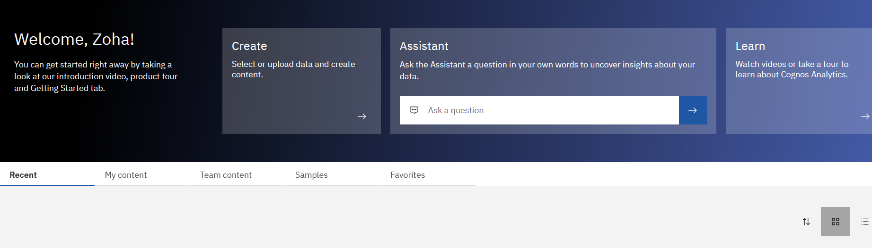

**Step 2 : select “new” menu and select data source . Upload your data set to “data modules”.**

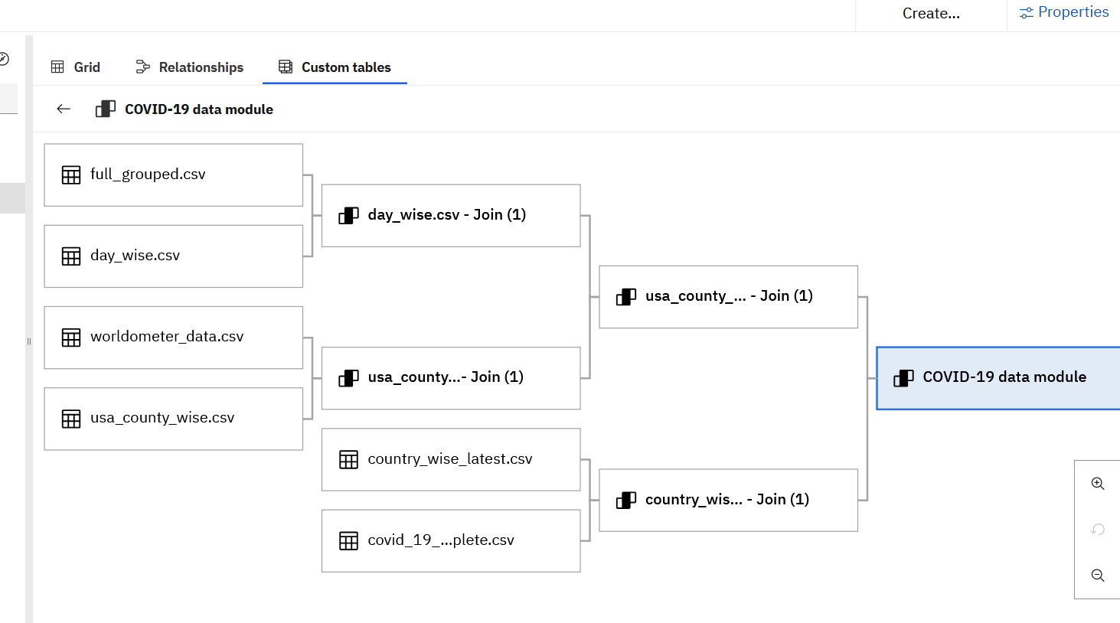

**Step 3: select “dashboard” and upload your module from “my content”.**

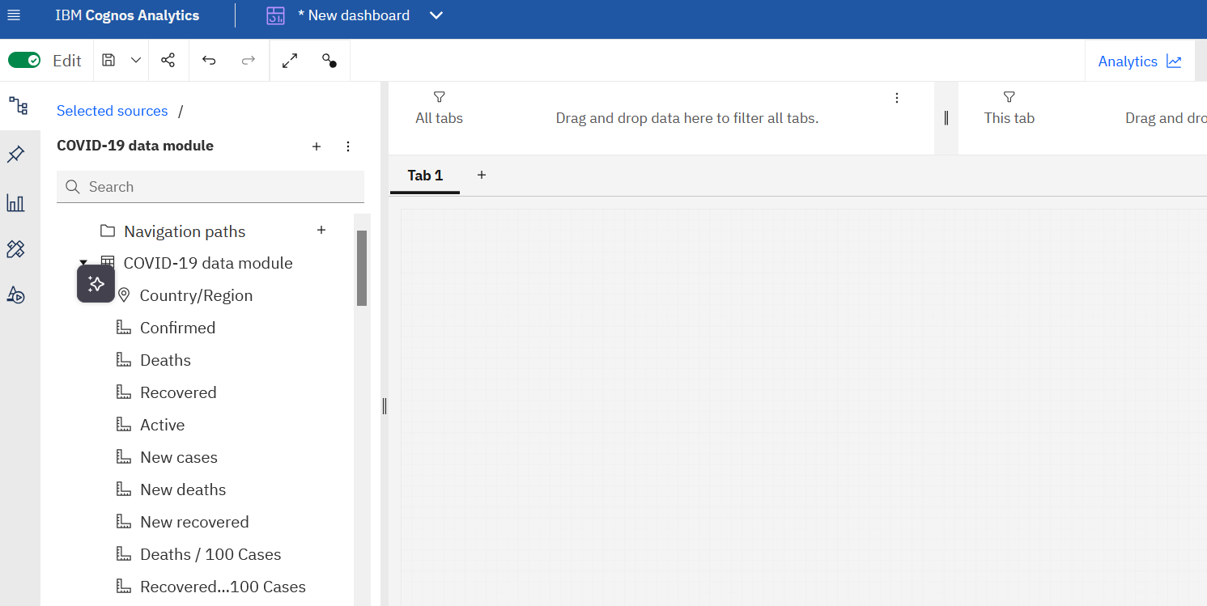

**Step 4 : for Tab 1**

### 1: Click KPI

Click on the **KPI** option in IBM Cognos Analytics to add a Key Performance Indicator card to your dashboard.

**What is KPI**

A KPI is a visual metric that shows important data points like totals or trends at a glance.

**Drag Confirmed Cases**

Drag the **Confirmed** column from your dataset to the **Base Value** field of the KPI.

**Set Base Value**

Set the aggregation to **SUM** so it shows the total confirmed cases globally.

**Set Target Value (Optional)**

Leave **Target Value** blank, or use previous day/month totals to show a comparison.

**Repeat for Other KPIs**

Repeat the above steps for **Deaths**, **Recovered**, and **Active Cases** (use [Confirmed] - ([Deaths] + [Recovered]) for Active Cases).

**Arrange the Dashboard**

Place the four KPI cards at the top of the tab and add a world map below to show global distribution.

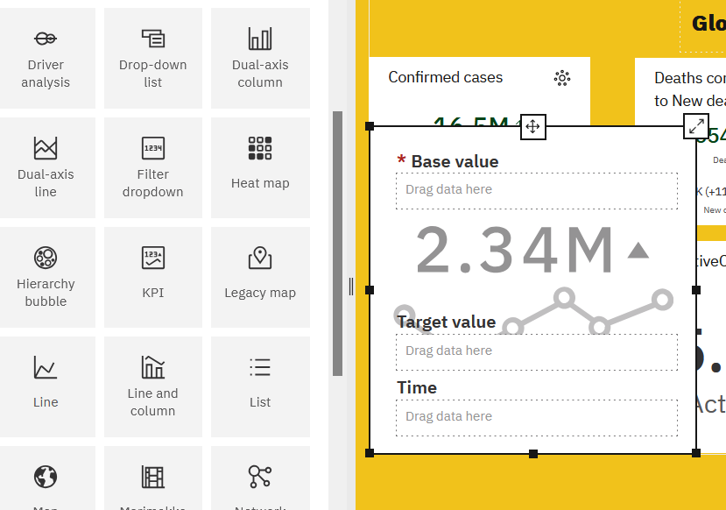

### ****Add Image****

To add an image, click the **Insert Image** option in IBM Cognos Analytics.  
You can either **upload the image from your computer** or paste a **direct image URL**.  
Adjust the **size and position** of the image on the dashboard as needed.

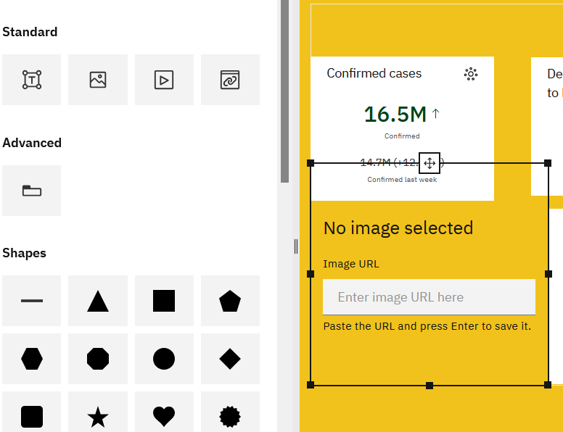

**TAB 1**

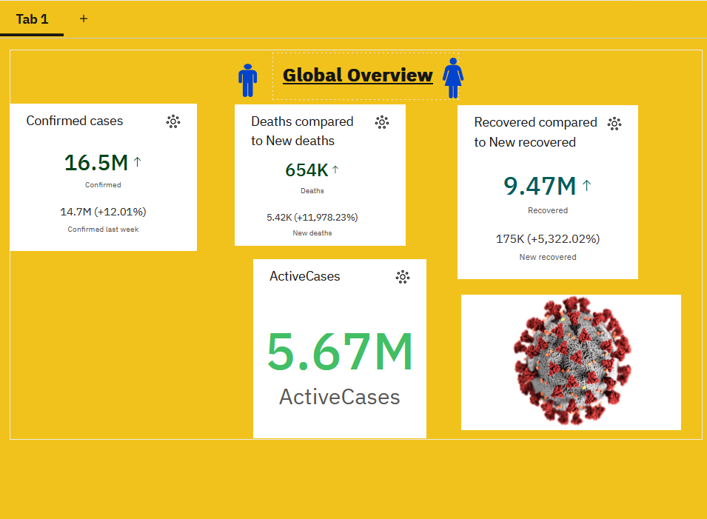

**Step 5: for tab 2**

### ****Steps to Create****

1. Click **Visualization → Bar Chart** (or Column Chart) in Cognos.
2. Drag **Country/Region** to the **Category/Axis** field.
3. Drag **Confirmed Cases** (or Deaths/Recovered) to the **Measure/Value** field and set aggregation to **SUM**.
4. Sort the chart to show **top 10 countries** with highest confirmed cases.
5. Add **colors** to differentiate cases: red for deaths, green for recovered, orange for active.

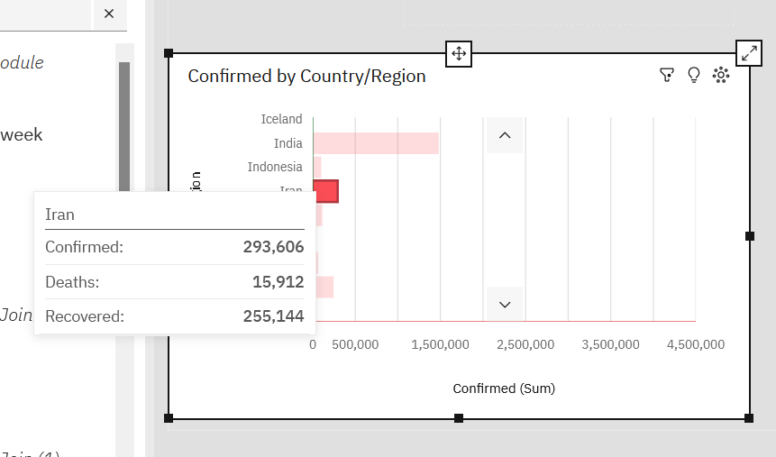

**TAB 2:**

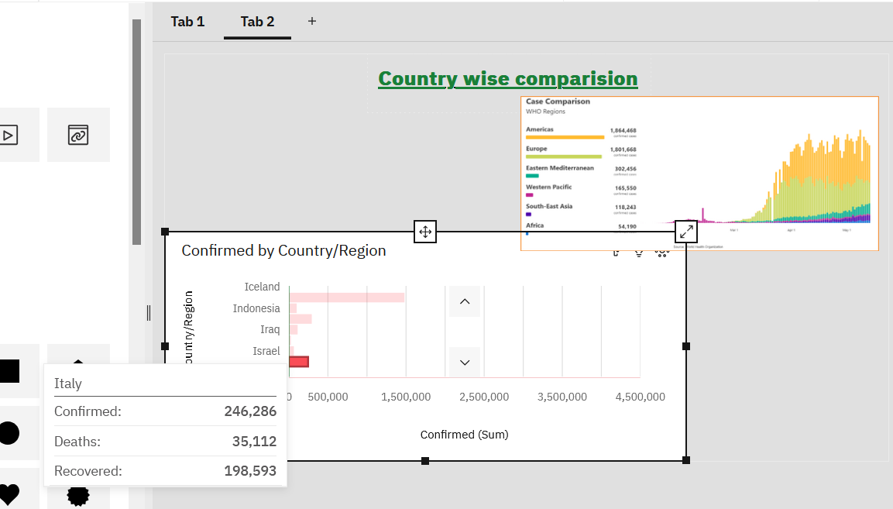

### ****Tab 3: Trend Analysis Over Time****

This tab visualizes the **daily or cumulative trends** of COVID-19 worldwide.

### ****Steps to Create****

1. **Click Visualization → Line Chart**
   * Line charts are best for showing changes over time.
2. **Drag Date to x-axis**
   * Shows the timeline from the start of the pandemic to the latest date.
3. **Drag Confirmed, Deaths, Recovered, Active Cases to y-axis (Length/Measure)**
   * Set aggregation to **SUM**.
   * For Active Cases, use the calculated field: [Confirmed] - ([Deaths] + [Recovered]).
4. **Add Colors**
   * Assign a different color for each metric:
     + Confirmed → Blue
     + Deaths → Red
     + Recovered → Green
     + Active → Orange

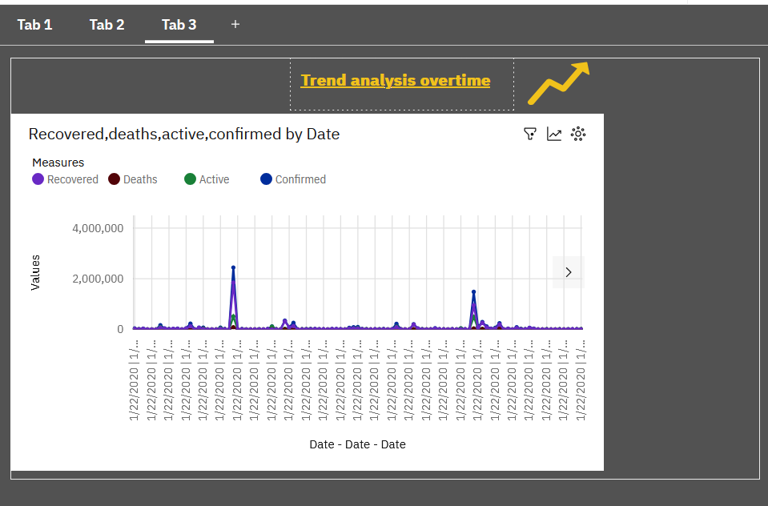

### ****Tab 4: Active vs Recovered vs Death Cases****

This tab shows the **distribution of COVID-19 cases** to quickly compare active, recovered, and death counts.

### ****Steps to Create****

1. **Click Visualization → Pie Chart or Donut Chart**
   * These charts are best for showing proportions.
2. **Drag the Metrics to the Measure/Length Field**
   * **Active Cases:** [Confirmed] - ([Deaths] + [Recovered])
   * **Recovered Cases:** Recovered
   * **Deaths:** Deaths
   * Set aggregation to **SUM**.
3. **Drag Metric to Color**
   * Assign colors: Active → Orange, Recovered → Green, Deaths → Red

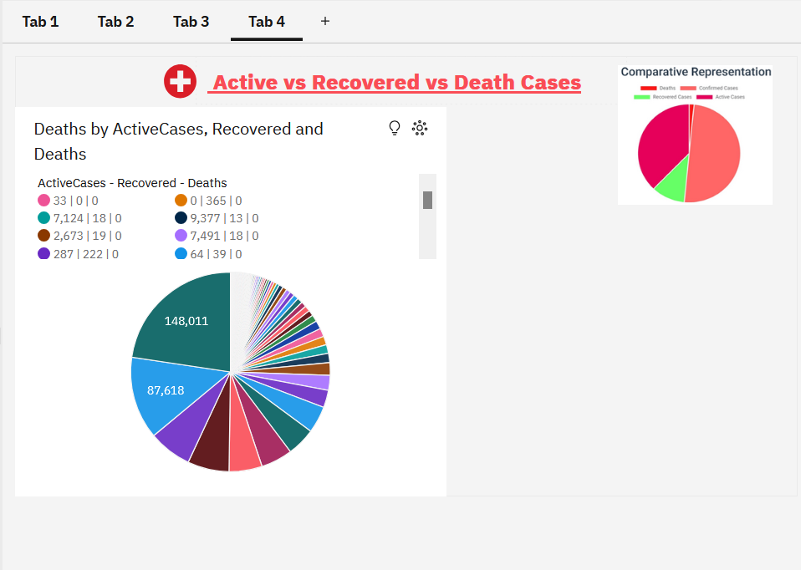

**TAB 5:**

### ****Steps to Create:****

1. **Click on Visualization → Area Chart**
   * This chart shows both deaths and recoveries stacked or overlapping over time.
2. **Drag “Date” to the x-axis**
   * This sets the horizontal timeline for the chart.
3. **Drag “Deaths” and “Recovered” to the y-axis**
   * Shows total deaths and recoveries over time (aggregation: **SUM**).
4. **Drag the metric name to “Color”**
   * Assigns different colors to each area:
     + Deaths → Red
     + Recovered → Green

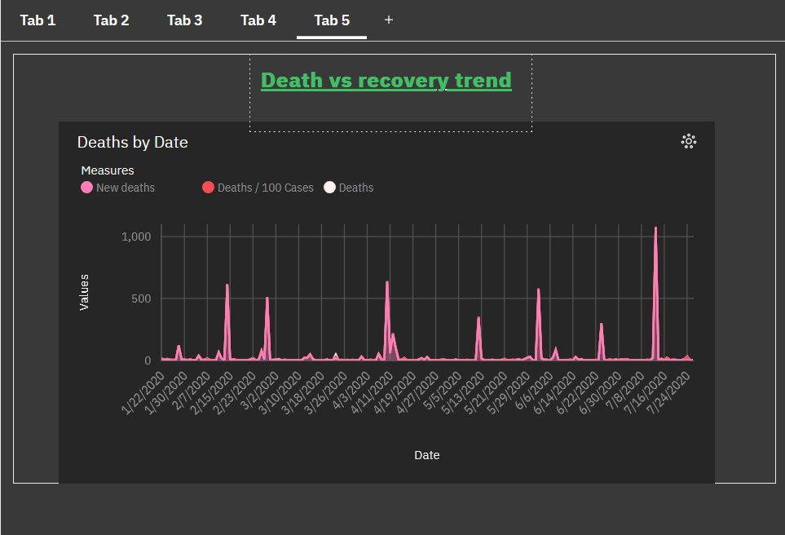

**TAB 6:**

### ****Steps to Create:****

1. **Create a Calculated Field**
   * Go to the **Data** panel.
   * Click on the **three dots (⋮)** beside your dataset and choose **Create Calculation**.
   * ***Type the formula:***

***([Deaths] / [Confirmed]) * 100***

Name it **“Mortality Rate (%)”** and click **Create**.

• **Add a Bar Chart Visualization**

* Click **Visualization → Bar Chart** from the toolbar.

• **Drag Fields into the Bar Chart**

* **Bars →** Country/Region
* **Length →** Mortality Rate (%)
* Add a Caption or Text

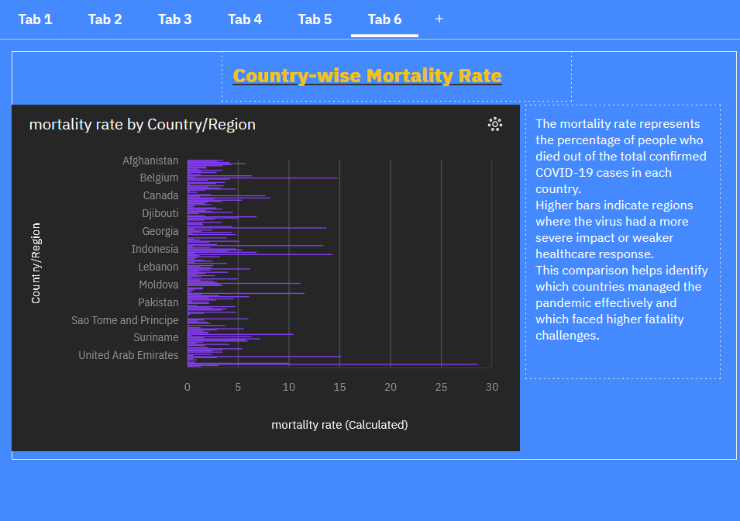

## **Tab 7: Recovery Rate by Country**

### ****Steps to Create:****

1. **Create a Calculated Field**
   * Go to the **Data** panel → click the **three dots (⋮)** beside your dataset → **Create Calculation**.
   * Enter this formula:

*([Recovered] / [Confirmed]) * 100*

Name it **“Recovery Rate (%)”** and click **Create**.

• **Click on Visualization → Column Chart**

* A column chart gives a clean view of recovery rates per country.

• **Drag Fields into the Chart**

* **Bars →** Country/Region
* **Length →** Recovery Rate (%)
* **Color →** Recovery Rate (%) *(optional — use green shades for better recovery)*
* **Tooltip →** Country/Region, Recovery Rate (%)

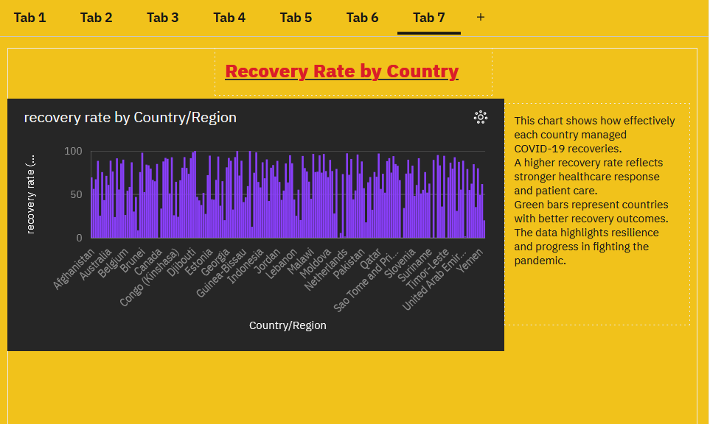

**Tab 8: Active Cases vs Confirmed Cases**

### ****Steps to Create:****

1. **Create a Calculated Field for Active Cases**
   * Go to **Data → Create Calculation**.
   * Formula:

*[Confirmed] - ([Deaths] + [Recovered])*

Name it **“Active Cases”**.

• **Click Visualization → Stacked Column Chart or Bar Chart**

* A stacked chart shows Active vs Resolved (Recovered + Deaths) cases clearly.

• **Drag Fields into the Chart**

* **Bars →** Country/Region
* **Length →** Active Cases and Resolved Cases
  + Optionally, create **Resolved Cases** = [Deaths] + [Recovered] as a calculated field.
* **Color →** Assign:
  + Active Cases → Orange
  + Resolved Cases → Green/Gray
* **Tooltip →** Active Cases, Resolved Cases, Country/Region
* **Local Filters →** Date or Continent
* 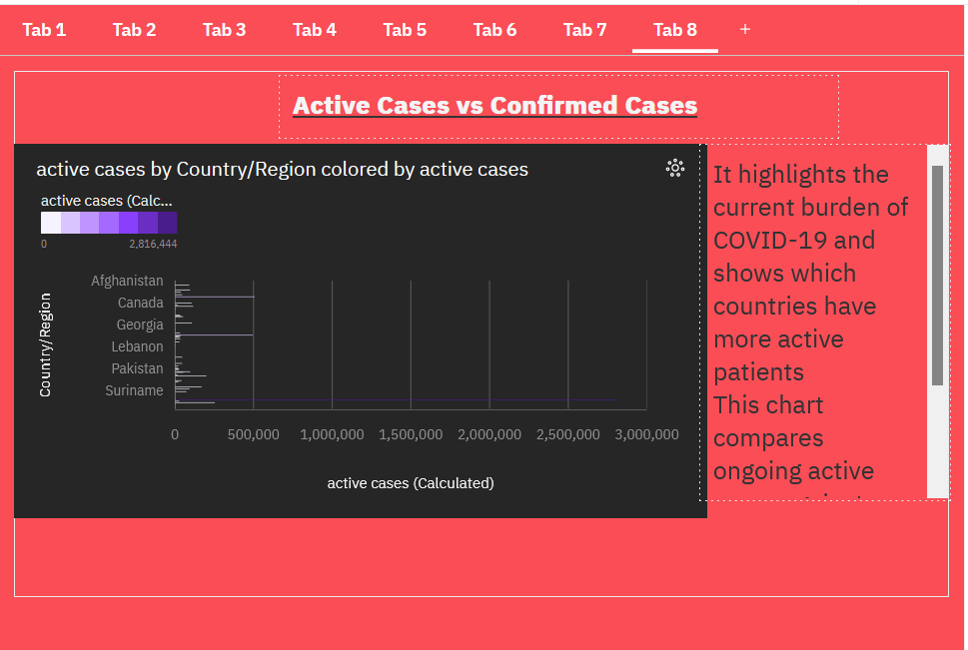

**TAB 1**

**TAB 2:**

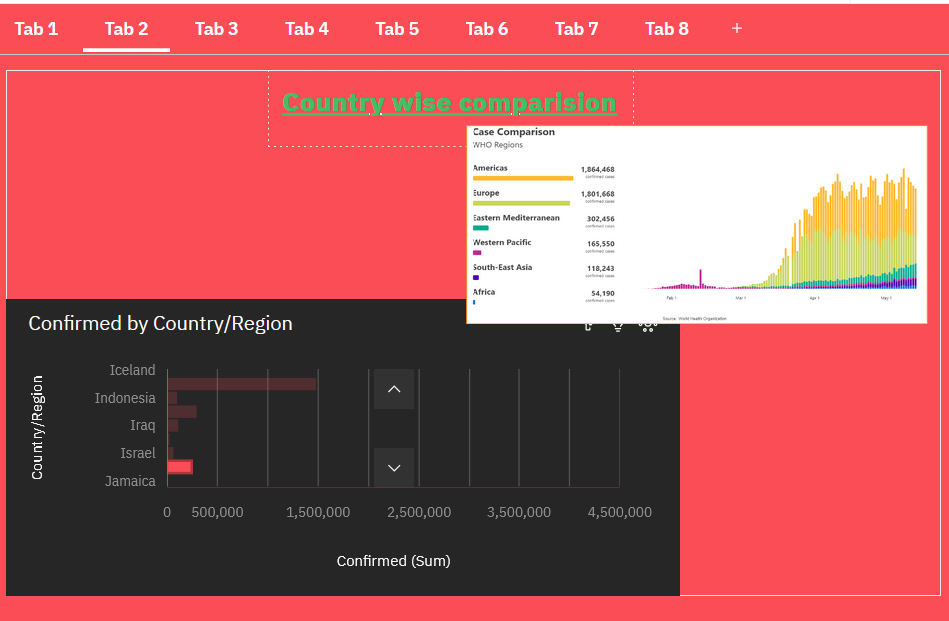

**TAB 3:**

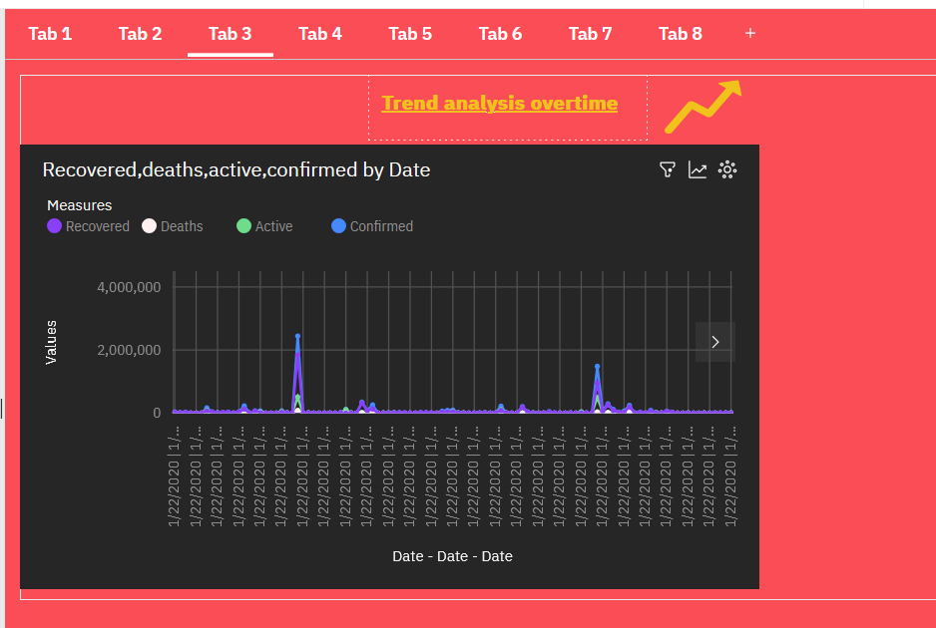

**TAB 4:**

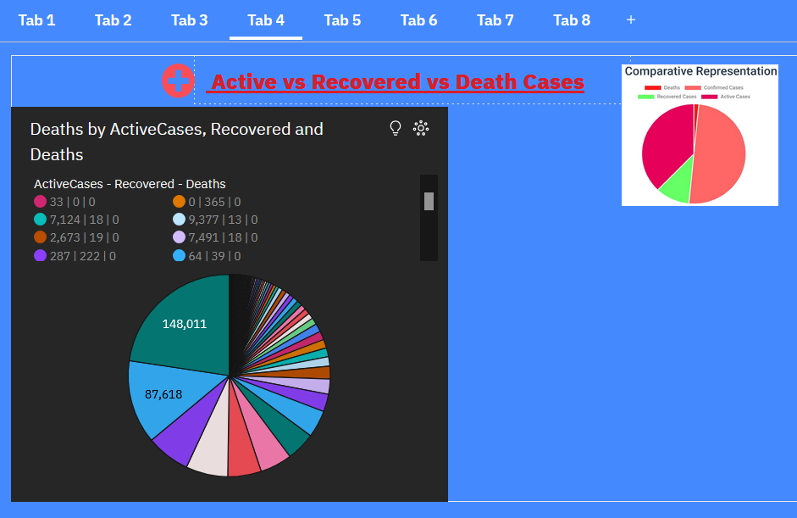

**TAB 5:**



**TAB 6:**



**TAB 7:**



**TAB 8:**



| **Tab No.** | **Tab Name** |  |
| --- | --- | --- |
| 1 | **Global Overview** | Total cases, deaths, recoveries snapshot |
| 2 | **Country-wise Comparison** | Compare confirmed cases by country |
| 3 | **Trend Analysis Over Time** | Cases progression over time graph |
| 4 | **Active vs Recovered vs Death Cases** | Proportion of case types displayed |
| 5 | **Death vs Recovery Trend** | Daily deaths versus recoveries trend |
| 6 | **Country-wise Mortality Rate** | Death percentage by country chart |
| 7 | **Recovery Rate by Country** | Recovery percentage comparison per country |
| 8 | **Active Cases vs Confirmed Cases** | Current active versus total cases |